Machine Learning-Based Diagnosis and Prediction of Three Major Types of Brain Stroke

Project Guide

Dr. Vanajaroselin Chirchi

Professor

Dept. of Information Science and Engineering

Dayananda Sagar Academy of Technology and Management, Bangalore.
Basavantappa Vathar
Information Science and Engineering
Dayananda Sagar Academy of Technology and Management
Bangalore
Prateek D
Information Science and Engineering
Dayananda Sagar Academy of Technology and Management
Bangalore.

Yashwanth H. L.
Information Science and Engineering
Dayananda Sagar Academy of Technology and Management
Bangalore.

Pradeep Dinesh Loni
Information Science and Engineering
Dayananda Sagar Academy of Technology and Management
Bangalore.

Abstract — Stroke remains one of the leading causes of mortality and long-term disability worldwide, affecting individuals across all age groups. When​‍​‌‍​‍‌​‍​‌‍​‍‌ a blockage or rupture cuts off the blood supply to the brain, it is referred to as a stroke. Strokes may result in the death of brain cells due to the lack of oxygen and cause the impairment of body movement, speech, and thinking. Thus, early prediction and diagnosis play a crucial role in lessening the impact of strokes and obtaining a more favorable patient recovery. This study presented a machine-learning-based system to identify and predict strokes from clinical tabular data that depict the three major types of brain strokes: ischemic, hemorrhagic, and transient ischemic attack (TIA). The system uses parameters of the patient including age, blood pressure, glucose, BMI, heart disease and lifestyle (smoking and alcohol) to calculate the probabilities of stroke. Several state-of-the-art models and algorithms like Convolutional Neural Networks (CNN) and Gradient Boosting (GB) are implemented to a certain extent which makes the prediction of stroke precise and trustworthy. The device is equipped with data preprocessing, feature selection and hyperparameter tuning operations to assure the system's proper functioning. The suggested model results in the facilitation of the early detection of a stroke, rapid clinical decision-making, and eliminating the need for expensive imaging procedures, thus, allowing healthcare to be of higher quality and more accessible.
I. INTRODCUTION
Stroke has become one of the most important health issues facing the world today as it is considered to be one of the major causes of mortality and long-term disability across the globe. It happens when the blood supply to the brain is blocked or burst, leading to the death of the brain cell and disabling the body to perform its necessary functions through movement, speech, memory and reasoning. World Health Organization (WHO) ranked stroke as the second leading cause of death and the third leading cause of long term disability in the world, with the rate of occurrence raising by almost half in the past twenty years. This is a concerning development that requires enhanced preventive and diagnostic interventions.
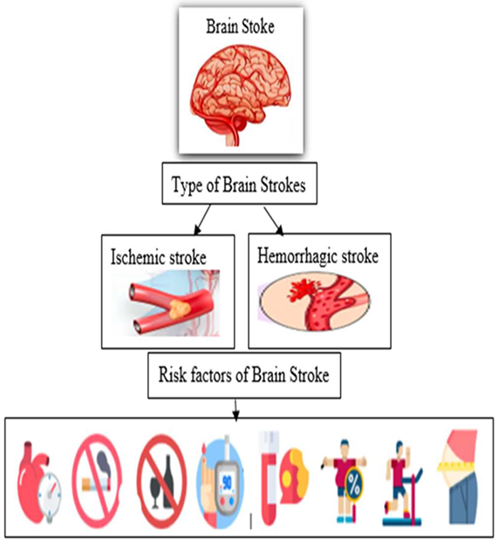
Fig. 1. Brain stroke prediction type and causes.

There are three principal types of strokes:
1. Ischemic Stroke: which occurs when a blood clot blocks blood flow to the brain, accounting for approximately 87% of all stroke cases.
2. Hemorrhagic Stroke: which is caused by a ruptured blood vessel in the brain that causes internal bleeding.
3. Transient Ischemic Attack (TIA): commonly termed “mini-stroke,” which is caused by a brief cessation of blood flow, and results in short-lived neurological symptoms.
It is important to identify individuals at high risk of stroke early in order to facilitate timely health care interventions and lifestyle adjustments. Conventional methods of diagnosis, such as imaging and blood tests, are valid if not too cumbersome, expensive and often not available in rural or resource-limited areas.
In recent years, the implementation of Artificial Intelligence (AI) and Machine Learning (ML) in medicine has sparked new ideas around early stroke prediction or risk stratification. In particular, ML models can analyze vast amounts of medical data to discern imprecise patterns correlated with a stroke. This study aims to develop an ML-based predictive system that utilizes clinical and lifestyle parameters—including age, blood pressure, glucose levels, heart disease history, body mass index (BMI), smoking, and alcohol consumption—to predict the risk and classify the type of stroke.
Feature​‍​‌‍​‍‌ selection and hyperparameter tuning will also be utilized to make the system more accurate. The developed model functions as a reliable source of information for doctors in the early diagnosis phase and clinical decision-making, thus reducing the need for expensive diagnostic tests and providing stroke prediction at a lower cost, with higher accessibility, and less time ​‍​‌‍​‍‌consumption.

II. LITERATURE REVIEW
Early​‍​‌‍​‍‌ detection and preventive measures are still very necessary to reduce the number of deaths and long-term disabilities that result from brain stroke, which is one of the most significant global health problems. In the future, Machine Learning (ML) can be considered a revolutionary technology to be used in stroke risk assessment based on various clinical datasets that include demographic, physiological, and lifestyle data. With such data-driven modeling, ML eventually locates the patients who are at risk and makes the interventions in a timely manner to be used in preventive care and precision-based healthcare decisions.
A. Ensemble Learning Approaches
Ensemble learning or the idea of figuring out several weak learners with a predictive model of a strong one has been able to show a very remarkable promise in the tasks of stroke prediction. The ensemble methods are capable of finding the complex, nonlinear relationships between different variables and also improving the generalization ​‍​‌‍​‍‌performance. The study in [1] developed a predictive model for six-month post-stroke outcomes using genetic, environmental, and clinical factors, where the XGBoost algorithm achieved superior discriminative ability (AUC = 0.818) compared to logistic regression (AUC = 0.756, p < .05). Similarly, the research in [2] showed that Gradient Boosting achieved the highest accuracy (96%), outperforming XGBoost (92%) and Decision Tree models (91%), establishing ensemble methods as highly reliable predictors for stroke risk based on multimodal clinical data.
Random Forest (RF), as an ensemble method, has been continuously shown as a strong performer in studies. Investigation [7] showed RF was superior in nearly all metrics when measured against traditional and deep learning algorithms, achieving the best sensitivity, specificity, F1 score, and ROC-AUC. Study [6] confirmed boosting algorithms, especially Gradient Boosting and XGBoost, achieved accuracy rates between 96%-96.97%, affirming their stability for stroke prediction. In this study, a standard Gradient Boosting Classifier is used, which is characterized by its iterative optimization algorithm that reduces prediction error through gradient descent in an additive structure. It is suitable for ROI data and structured tabular stroke datasets due to the potential for varying clinical features.

B. Deep Learning Architectures
Deep Learning (DL) models have transformed predictive modeling by learning complex hierarchical representations directly from data. Specific architectures such as, Convolutional Neural Networks (CNNs) and Recurrent Neural Networks (RNNs), can demonstrate appropriate capabilities to recognize, interpret, and predict stroke. spatial and temporal dependencies within medical data.
The research in [8] demonstrated that Long Short-Term Memory (LSTM) models achieved a sensitivity of 96.15%, while Feedforward Neural Networks (FNNs) exhibited superior specificity, accuracy, and ROC-AUC scores. Equally, research [3] involved a mix of multi-PLD ASL CBF radiomics and clinical characteristics in SVM-based method, and the AUC is as high as 0.832 -0.904. In the present study, stroke risk classification is performed with the Convolutional Neural Network (1D-CNN) that is appropriate to work with sequential and structured clinical data because it finds the local dependency between features using convolutional filters.They have a hierarchical property of extracting features which increases the representation learning property and can hence increase the accuracy of the classification without heavy feature engineering. In line with [10], CNN-based models have a maximum accuracy of 98 percent, therefore proving to be effective in non-imaging clinical uses.

C. Feature Analysis and Predictive Factors
During the exploration of characteristics of the previous research, it was always indicated that age, average glucose and body mass index (BMI) had the greatest impact on the risk of stroke. Study [1] has acknowledged environmental aspects including PM2.5, PM10, CO levels, and temperature were key predictors of stroke, alongside lifestyle factors, such as smoking, drinking, absence of physical activity, etc.
Neurological parameters (including the National Institutes of health Stroke Scale, NIHSS) score might also predict the outcomes; in [3], the baseline NIHSS score was the primary predictor in the SHAP ( Shapley Additive explanations) analysis. In addition, it is worth noting that the article [5] found that age was the most correlated factor (r = 0.25) with stroke. This is because the stroke risk factor is multi-factorial in nature and is composed of the demographic, metabolic, behavioral, and environmental factors, which contribute to the prediction of the stroke risk.

D. Interpretability and Explainability of Models
The intercept ability remains one of the primary issues of the clinical use of ML models. To support it, explainable artificial intelligence (XAI) algorithms like SHAP and LIME (Local Interpretable Model-agnostic Explanations) have been embraced. Examples of such frameworks are shown in references [5] and [6] which, in addition to giving a measure of importance of global features also give a local decision ¹explanation. The SHAP analyses in [5] revealed that age, glucose level, and BMI were the most important predictors that significantly contributed to the model outputs and LIME made decisions at the instance level thus enhancing the confidence of the clinician on the model. In another instance, [3] utilized SHAP to evaluate the main contributors for SVM-based stroke outcome models as NIHSS, age, and infarct morphology/feature. Moreover, [4] quotes logistic regression as still being interpretable and transparent hence it can serve as a baseline model for validation of more complex models.

E. Multimodal Integration Strategies
Recent work mainly points towards the multimodal data integration, which merges clinical, genetic, environmental, and imaging attributes to improve the prediction ​‍​‌‍​‍‌​‍​‌‍​‍‌reliability. The framework in [1] incorporated genetic and environmental determinants, showing significant gains in predictive performance compared to single-modality models. Study​‍​‌‍​‍‌​‍​‌‍​‍‌ [3]‍‍‍‍ combined multi-PLD ASL CBF radiomics with clinical data to build a comprehensive outcome prediction model (AUC = 0.707-0.772). Similarly, [9] integrated carotid ultrasound imaging with clinical variables into a deep learning-based multimodal system and got a higher accuracy in the prediction of the stroke risk in hypertensive patients. These ways of integration show the transition of the support of more patient-centred comprehensive predictive models, that is, they make clinical decision in the real ‍‌‍‍‌world easier.

F. Challenges in Developing the Model
The promising results still have a number of methodological challenges. Class imbalance (i.e. the situation where cases of stroke are underrepresented) is one of the most serious problems. In its report, the study [4] stated that the dataset used had only 4.9% stroke cases and used random oversampling to mitigate the imbalance and bias but this can cause the development of those models which tend to overfit, or are not generalisable. The next level of the problem with the model is that there exists the risk of a population bias in that a model developed by a particular population might not be relevant in another population. As an example, the findings made by basing on the genetic qualities of the Chinese group in [1] might not be applicable to other non-Chinese nations and other groups. Moreover, [8] also stressed the need to have bigger sample sizes and external validation because it is necessary to understand the variability and minimize the chance of biased models. Finally, the application of clinical data on the evaluation of these models has certain technical issues like feature redundancy which might enhance variability of the datapoints, the studies might vary in data examined and the variability of measurements of cognitive tests that may not have been factored in. Similarly, it is equally crucial to design and modify model evaluation in future researches on clinical implementation..

G. Clinical Performance Comparison
The performance of ensemble learning techniques, as well as deep learning models, was found to exceed that of traditional statistical models. Specifically, study [2], having applied Gradient Boosting as their primary analysis model, achieved an overall accuracy of 96%. In study [10], the Random Forest model generated an accuracy of 99.07%, achieving high levels in each of the individual model metrics within their approach, while Gradient Boosting achieved a model accuracy of 97.05%. Study [4] utilized logistic regression and produced model accuracy of 95.11%, with an ROC-AUC of 0.8362 for overall interpretation of the model, but it lacked slight predictive power compared to the aforementioned models. While study [8] applied deep learning models (i.e. CNN, LSTM, FNN) and revealed improvements to traditional machine learning algorithms, in the outcome measures, Random Forest remained on par for overall metrics to being the best in model performance. Study [3] examined option of utilizing SVM comprehensive model and were able to achieve an AUC of 0.904, which surpassed their previous results of applying XGBoost.

In sum, the data indicates that Gradient Boosting and 1D-CNN as employed in this study, represent convergence, interpretable prediction paradigms which not only allow for highly reliable modeling, but produce hybrid approaches which allow for both high levels of accuracy, as well as clinical relevance in stroke prediction. Gradient Boosting models prove to be diagnostic value and resilient on structured clinical data, while 1D-CNN allows for representation learning and feature abstraction.

III. METHOD
A. Data Collection
The dataset used in this study was obtained from Kaggle [23], comprising structured patient medical records for stroke prediction. It is a publicly available dataset that contains information on 13,486 patients and their associated clinical and lifestyle features.
The dataset includes the following attributes:
- Gender
- Age
- Hypertension
- Heart Disease
- Ever Married
- Family History
- Work Type
- Residence Type
- Average Glucose Level
- Body Mass Index (BMI)
- Smoking Status
- Alcohol Consumption
- Diabetes
- Blood Pressure (Systolic and Diastolic)
- Cholesterol
- White Blood Cell (WBC) Count
- Red Blood Cell (RBC) Count
Each record represents an individual patient’s clinical profile and corresponding stroke outcome. The target variable denotes stroke risk levels as follows:
- 0 – No Stroke (Healthy)
- 1 – Ischemic Stroke
- 2 – Hemorrhagic Stroke
- 3 – Transient Ischemic Attack (TIA)
Originally, the Kaggle dataset classified the output as binary (0 = No Stroke, 1 = Stroke Detected). In this research, the target variable was expanded to a multidimensional class level, which demonstrated the inclusion of different types of stroke. This dataset allows for a comprehensive representation of the medical and lifestyle characteristics that are associated with stroke risk, and it will support training, testing, and evaluating any models built around predicting stroke risk.

B. Data Preprocessing
Data preprocessing is an important process in taking raw clinical data and preparing it for the appropriate training of a machine learning model. The dataset provided by Kaggle and used in this study contained a range of different clinical and lifestyle characteristics of patients, including both numerical and categorical data. Since the dataset included missing values and each attribute had varying scales, this necessitated the use of a range of preprocessing techniques to ensure the consistency and quality of the data was appropriate to maximize the efficiency of the model.

1. Handling Missing or Null Values
The dataset contained missing observations, specifically in the columns whitebloodcellcount, redbloodcellcount, bmi, and smoking_status.
The missing values were treated as follows:
•For all numerical attributes (BMI, WBC, RBC, Average Glucose Level) missing data were filled with mean values, to maintain the original distribution of the data overall.
•For categorical attributes (Smoking Status and Work Type), categories were imputed using the mode (most frequent category).
This method ensured that no observations were removed, maintaining the original dataset size and diversity.

2. Encoding Categorical Features
Categorical variables were transformed into numerical values so that machine learning algorithms could interpret them effectively.
- Features such as Gender, Ever Married, Work Type, Residence Type, and Smoking Status were encoded.
- Label Encoding was used for binary columns (e.g., Gender: Male = 1, Female = 2).
- One-Hot Encoding was applied to multi-category attributes such as Work Type and Smoking Status, creating separate binary columns for each unique class.
This conversion preserved categorical meaning without introducing ranking bias.

3. Normalization and Standardization
In order to remove the scale difference between numeric attributes such as Age, Average Glucose Level, BMI, Blood Pressure, and Cholesterol, feature scaling was conducted.
- Normalization (Min–Max scaling) scaled features to a range between 0 and 1.
- Standardization (Z-score scaling) changed features to have a mean of 0 and standard deviation of 1.
These processes aided model stability and made sure every feature contributed equally in the model trainings, especially for models sensitive to scaling, i.e., SVM and Gradient Boosting.

4. Outlier Detection and Removal
There were specific numeric columns Cholesterol, BMI, and
Glucose Level that had extreme values that could hinder the model's learning. Outliers were detected using the Interquartile Range (IQR) method. The extreme values were clipped to threshold limits or replaced with a median value so the process was validated for consistency.

5. Data Balancing
The variable output was imbalanced; it consisted of greater counts of No Stroke cases compared to (0) the Ischemic stroke (1), Hemorrhagic stroke (2), and TIA (3) strokes. Hence, a solution to remove the imbalance was to implement the Synthetic Minority Oversampling Technique( SMOTE), which created synthetic examples of the minority classes, allowing for balance among all represented types of stroke categories while also improving the classifier's ability to generalise.

6. Splitting the Dataset
The final pre-processed data was split into a training and testing set (80:20 ratio). Training set (80%) for learning model parameters and a testing set (20%) to test model quality. A​‍​‌‍​‍‌​‍​‌‍​‍‌ stratified split was carried out to guarantee that the proportions of class stroke and non-stroke samples are the same in the training and testing subsets. This was done to ensure that there is no bias in the testing of the model.

C. Feature Selection
Feature selection refers to choosing the most significant features (variables) in a dataset that have a strong correlation with the target variable - the occurrence and type of stroke. It​‍​‌‍​‍‌​‍​‌‍​‍‌ is referred to as one of the main factors that are taken into account when designing a machine learning model that is both accurate and efficient.

1. Objectives of feature selection
- Mitigate overfitting: The elimination of non-informative or redundant variables may lead to the removal of overfitting and situations where the noise in the data is memorized by the model.
- Optimize prediction accuracy: Models that are trained using only relevant features have higher prediction accuracy than models trained using all features.
- Facilitate interpretation: A handful of variables that still have significance will better help an audience to understand what variables influence the risk of stroke.
- Limit computational expense: As the number of variables gets smaller, the time for training and prediction also gets shorter. This is especially good for larger datasets.

2. Approaches taken
Your project mainly involved two methods:
- Correlation Analysis:
- When variables are interrelated and also related to the output (stroke class), correlation matrix views can help in getting a better understanding of the relationships between independent variables and the output (stroke classification).
- Variables that have a strong correlation with stroke risk (e.g., age, hypertension, glucose level) will be kept.
- Variables that have a strong correlation with each other (multicollinearity), or very low correlation to stroke, will be ​‍​‌‍​‍‌​‍​‌‍​‍‌removed.
Feature Importance using Gradient Boosting - Feature importance scores can be computed by Gradient Boosting models, and they are used to show the degree to which each feature is used for prediction accuracy.
- This​‍​‌‍​‍‌​‍​‌‍​‍‌ refers to the features that were age, blood pressure, BMI, heart disease, and average glucose level that were the most prominent and substantially contributed to stroke detection.

3. Result
After​‍​‌‍​‍‌​‍​‌‍​‍‌ applying these methods, only the most significant features were retained for model training. Apart from the prediction performance, this also raised the CNN and Gradient Boosting models' efficiency and interpretability.

Feature selection

By identifying the most factors that influence the risk of stroke, feature selection makes the model more accurate and efficient. On the other hand, gradient boosting uses a feature importance ranking to highlight the most features, while correlation analysis removes the redundant or unnecessary features. The most important variables are kept constant, i.e., age, blood pressure, BMI, and glucose level. This not only enhances the performance but also the interpretability by facilitating CNN and Gradient Boosting ​‍​‌‍​‍‌​‍​‌‍​‍‌‍‌‍‍‌‍‌‍‍‌models.

D. Model Development
The​‍​‌‍​‍‌​‍​‌‍​‍‌ development of the model involved the use of machine learning algorithms to achieve accurate prediction or classification of the stroke type in the case of a medical scenario. Locally, in this study, the two algorithms which authors have decided to deploy are Convolutional Neural Networks (CNN) and Gradient Boosting (GB) - technique.

1. Convolutional Neural Networks (CNN)
Convolutional neural networks are usually designed to process image information. Nonetheless, through 1-D convolutions, convolutions could be applied to assist CNNs to comprehend complex relationships in a structured table as well. The CNN model in this case consists of convoluting layers, activation function (ReLU), pooling layers (dimensionality reducing), and finally fully connected layers to give the output of the prediction. Regularization, as one form of dropout, is added to the network to prevent the memorization of the training data by the model. The loss function was a categorical cross-entropy loss with an Adam optimizer that was used to train the model.

2. Gradient Boosting (GB)
Gradient Boosting is one of such approaches, whereby one or more simple decision trees or weak learners are built at a time. Moreover, every new tree attempts to do better or better than the former ones. The approach is highly efficient with tabular clinical data, and, hence, is an excellent model of generating the feature importance measure of interpretability intent. Through cross-validation learning rate, estimators, and maximum depth were optimized to achieve the optimal predictive performance.

Training and Validation
The preprocessed and feature-selected dataset was split into training and testing sets (80:20 ratio). Stratified k-fold cross-validation was applied to ensure robust evaluation and to avoid bias from class imbalance. Performance metrics such as accuracy, precision, recall, F1-score, and confusion matrix were used to assess model effectiveness.
- Hyperparameter Optimization
Hyperparameters for both CNN and GB models were optimized using grid search and random search techniques to improve model generalization. For CNN, parameters like the number of layers, filter sizes, batch size, and learning rate were tuned. For Gradient Boosting, the number of trees, learning rate, and maximum depth were adjusted for optimal results.
- Outcome
The combined use of CNN and Gradient Boosting, along with careful preprocessing and feature selection, enabled accurate classification of ischemic, hemorrhagic, and TIA strokes. The models demonstrated strong predictive performance while maintaining interpretability, providing a reliable tool for early stroke detection and aiding clinical decision-making.

E. Model Evaluation
After training, the models are evaluated to determine their effectiveness in predicting stroke types. The evaluation uses standard performance metrics: Accuracy, Precision, Recall, and F1-Score.
- Accuracy
Accuracy measures the proportion of correctly classified instances out of the total samples.
$$\text{Accuracy}=\frac{TP+TN}{TP+TN+FP+FN}$$
- Precision
Precision indicates the proportion of correctly predicted positive cases out of all instances predicted as positive.
$$\text{Precision}=\frac{TP}{TP+FP}$$
- Recall (Sensitivity)
Recall measures the model’s ability to correctly identify actual positive cases.
$$\text{Recall}=\frac{TP}{TP+FN}$$
- F1-Score
F1-Score is the harmonic mean of Precision and Recall, providing a balanced metric especially useful for imbalanced datasets.
$$\text{F1-Score}=2×\frac{\text{Precision}×\text{Recall}}{\text{Precision}+\text{Recall}}$$
1. Performance Metrics
After training, the models are evaluated to determine their effectiveness in predicting different stroke types. The evaluation uses standard performance metrics such as Accuracy, Precision, Recall, and F1-Score, defined as follows:
Accuracy
Accuracy measures the proportion of correctly classified instances out of the total number of samples:
$$\text{Accuracy}=\frac{TP+TN}{TP+TN+FP+FN}$$
Precision
Precision indicates the proportion of correctly predicted positive cases out of all instances predicted as positive:
$$\text{Precision}=\frac{TP}{TP+FP}$$
Recall(Sensitivity)
Recall measures the model’s ability to correctly identify actual positive cases:
$$\text{Recall}=\frac{TP}{TP+FN}$$
F1-Score
The F1-Score is the harmonic mean of Precision and Recall, providing a balanced performance measure, particularly useful for imbalanced datasets:
$$\text{F1-Score}=2×\frac{\text{Precision}×\text{Recall}}{\text{Precision}+\text{Recall}}$$
Where:
- TP = True Positives
- TN = True Negatives
- FP = False Positives
- FN = False Negatives
These metrics collectively help identify the best-performing model and ensure reliable stroke prediction results.
2. Model Evaluation using LIME
In this study, the Local Interpretable Model-agnostic Explanations (LIME) technique is employed to interpret the predictions of the best-performing machine learning model — the Random Forest. LIME is a model-agnostic interpretability method, meaning it can be applied to any black-box model regardless of its internal structure.
The key idea behind LIME is to approximate a complex model locally (around a specific prediction) using a simpler, interpretable model such as a linear model or a decision tree. The primary objective is to enhance interpretability by identifying which features most influence a given prediction.
Let G represent the class of possible interpretable models, and let g ∈ G denote a specific interpretable model within that class. The complexity of model g is represented by Ω(g), which acts as a regularization term to penalize overly complex explanations. The value of Ω(g) depends on the model type—for instance, it may represent the depth of a decision tree or the number of non-zero coefficients in a linear model.
The general objective of LIME is to minimize the following loss function:
$$ξ(x)=arg⁡\underset{g∈G}{min⁡} L(f,g,π_{x})+Ω(g)$$
where:
- L(f, g, πₓ) measures the fidelity between the original model f and the interpretable model g around the instance x,
- πₓ defines the locality around x, assigning higher weights to samples closer to x, and
- Ω(g) represents the complexity of the explanation model.
Therefore, we ensure that the explanation model g is as high-fidelity as possible (accurate) while maintaining low complexity (interpretable).

3. Model Evaluation via SHAP
SHAP, or SHapley Additive exPlanations, is an additional model-agnostic interpretability technique adopted in this study. SHAP, a method based on Shapley values from cooperative game theory, considers each feature as a "player" that contributes to the model's final prediction, regarding the model’s output as the total "payout." Like other cooperative games, Shapley values distribute this total contribution of the features in an equitable way based on the marginal contributions the players make to the overall outcome of interest.
SHAP provides explanations at both the global and local levels:
• Global level – the overall importance of each feature to the final model.
• Local level – how much each feature contributed to a model-based prediction for a single observation.
By providing both global and local level explanations, SHAP offers insight into the behavior of the model as a whole, and can provide an understanding of why a particular model made a specific prediction.
An optimization of SHAP, TreeSHAP, was developed to compute Shapley values efficiently in tree-based models such as Random Forest, Gradient Boosted Trees, and XGBoost. TreeSHAP was shown to give exact estimates of Shapley values without the excess computational burden on these important classes of models, making it potentially useful for inference in large scale applications.

IV. RESULTS AND DISCUSSION
Following feature selection, data preprocessing, and model optimization, the prepared stroke dataset was used to train and assess two sophisticated models: Convolutional Neural Network (CNN) and Gradient Boosting (GB). 18 features that represent clinical and lifestyle factors influencing stroke risk were chosen from 2,685 samples to test both models.

A. Model Evaluation Metrics
Accuracy, precision, recall, and F1-score were calculated for each class (No Stroke, Ischemic Stroke, Hemorrhagic Stroke, and Transient Ischemic Attack) in order to evaluate the model's performance. Below is a summary of the findings.
1. Gradient Boosting Results
- Performance Metrics
The Gradient Boosting model achieved an impressive test acc-
uracy of 98.25%, outperforming other baseline models. It demonstrated high precision and recall across all four classes, indicating robust generalization and minimal misclassification.
Class | Precision | Recall | F1-Score | Support
0 (No Stroke) | 1.00 | 0.93 | 0.96 | 644
1 (Ischemic Stroke) | 0.94 | 1.00 | 0.97 | 698
2 (Hemorrhagic Stroke) | 1.00 | 1.00 | 1.00 | 698
3 (Transient Ischemic Attack -– TIA) | 1.00 | 1.00 | 1.00 | 645
Accuracy |  |  | 98.25% | 2685
Macro Average | 0.98 | 0.98 | 0.98 | 2685
Weighted Average | 0.98 | 0.98 | 0.98 | 2685
Table: Gradient Boosting Performance evaluation table
The macro-average and weighted-average F1-scores were both 0.98, confirming the balanced predictive performance of the Gradient Boosting model across all stroke types. Its interpretability through feature importance scores further validates the clinical relevance of key predictors such as age, hypertension, blood pressure, glucose level, and BMI.
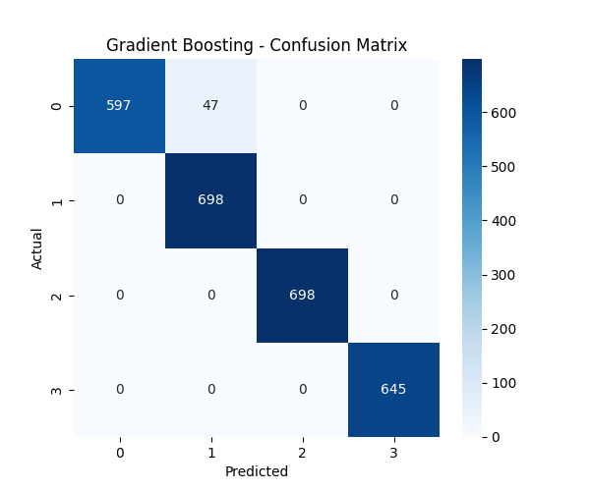
Figure: Testing Performance Metrics Result

2. Local Interpretability (LIME)
LIME (Local Interpretable Model-agnostic Explanations) was used to analyze individual predictions and understand the model's reasoning on a case-by-case basis. Explanations were generated for five sample instances from the test set.
Case Study: Instance 1 (True Label: Class 2, Predicted: Class 2) For a sample correctly predicted as Class 2, LIME revealed the features contributing to this decision. The model's prediction (with 99.2% probability) was the result of a "tug-of-war" between features:

- Features supporting the 'Class 2' prediction (Positive Contribution):
  - -0.13 < whitebloodcellcount <= 0.15: +0.2417
  - -0.26 < cholesterol <= 0.54: +0.1104
  - family_history > -0.50: +0.0688
  - -0.46 < redbloodcellcount <= 0.12: +0.0310
- Features opposing the 'Class 2' prediction (Negative Contribution):
  - age > 0.92: -0.1659
  - -0.96 < residence_type <= 1.04: -0.0731
  - alcohol <= -0.95: -0.0560
  - avg_glucose_level > 0.16: -0.0255
This analysis shows the model's reasoning. For the Gradient Boosting model, the prediction was primarily driven by whitebloodcellcount and cholesterol, while a high age value acted as the strongest opposing factor.

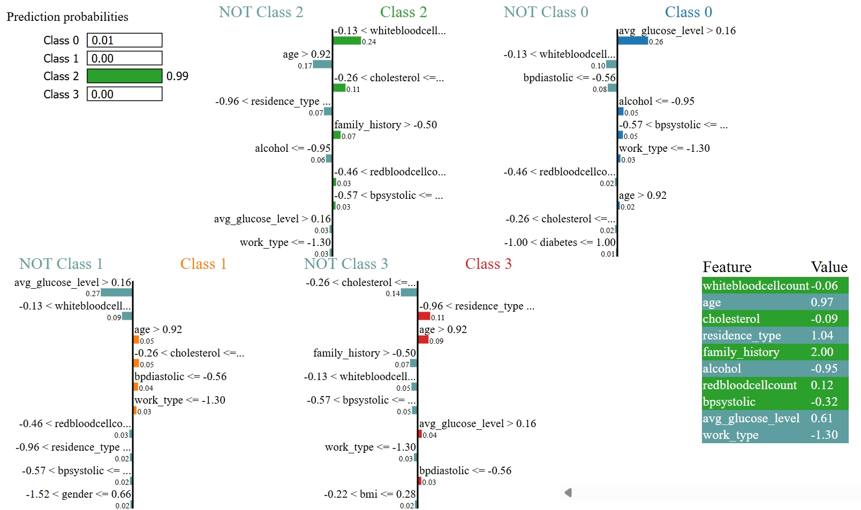

Figure: LIME-based local interpretability for the CNN model

3. Global Interpretability (SHAP)
To understand the global importance of each feature and its impact on the model's predictions, a SHAP (SHapley Additive exPlanations) analysis was conducted. The shap.PermutationExplainer method was used to compute SHAP values for a subset of 100 samples from the test data.
The analysis successfully generated a comprehensive set of visualizations to interpret the model's behavior:
- Global Feature Importance (Bar Plot): A summary bar plot was created (see shap_summary_bar.png), illustrating the mean absolute SHAP value for each feature. This plot provides a clear ranking of which features, on average, have
e most significant impact on the model's predictions.
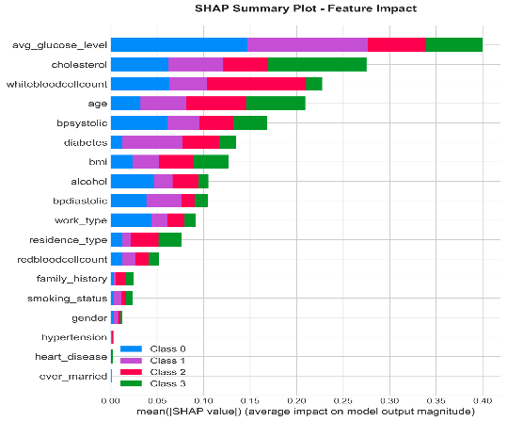
- Figure: Shap Summary Bar
- Feature Impact Summary (Beeswarm Plot): A beeswarm plot (see shap_summary_beeswarm.png) was generated to visualize not only the magnitude of each feature's importance but also the direction of its impact.
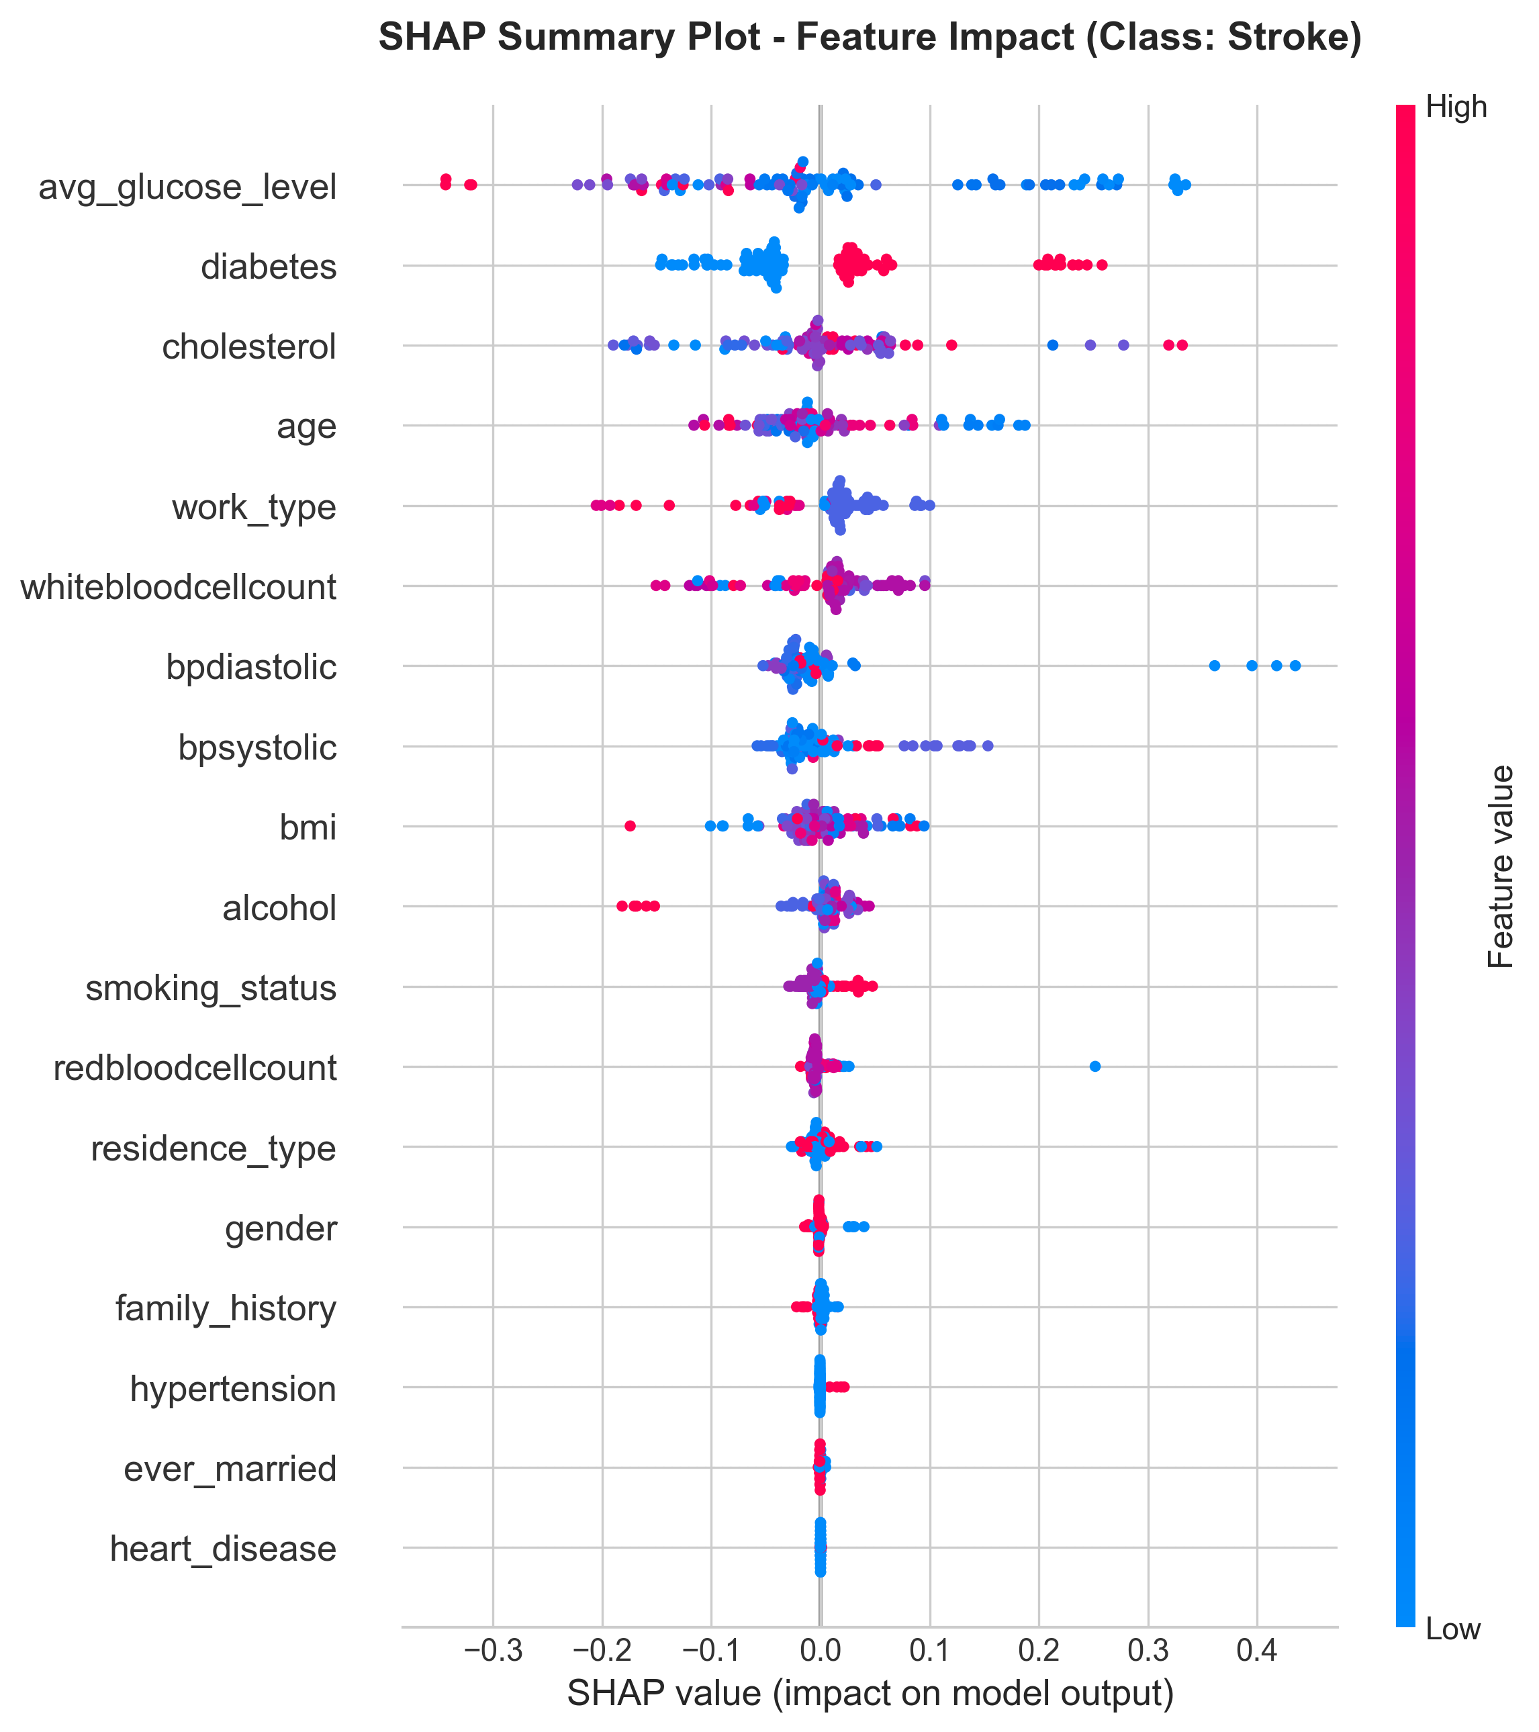
Figure: Shap Summary Beeswarm
Dependence Plots: To dive deeper into feature interactions, dependence plots were successfully generated. These plots detail the relationship between a single feature's value and its corresponding SHAP value. Based on the analysis, the top four most influential features identified were avg_glucose_level, cholesterol, whitebloodcellcount, and age.
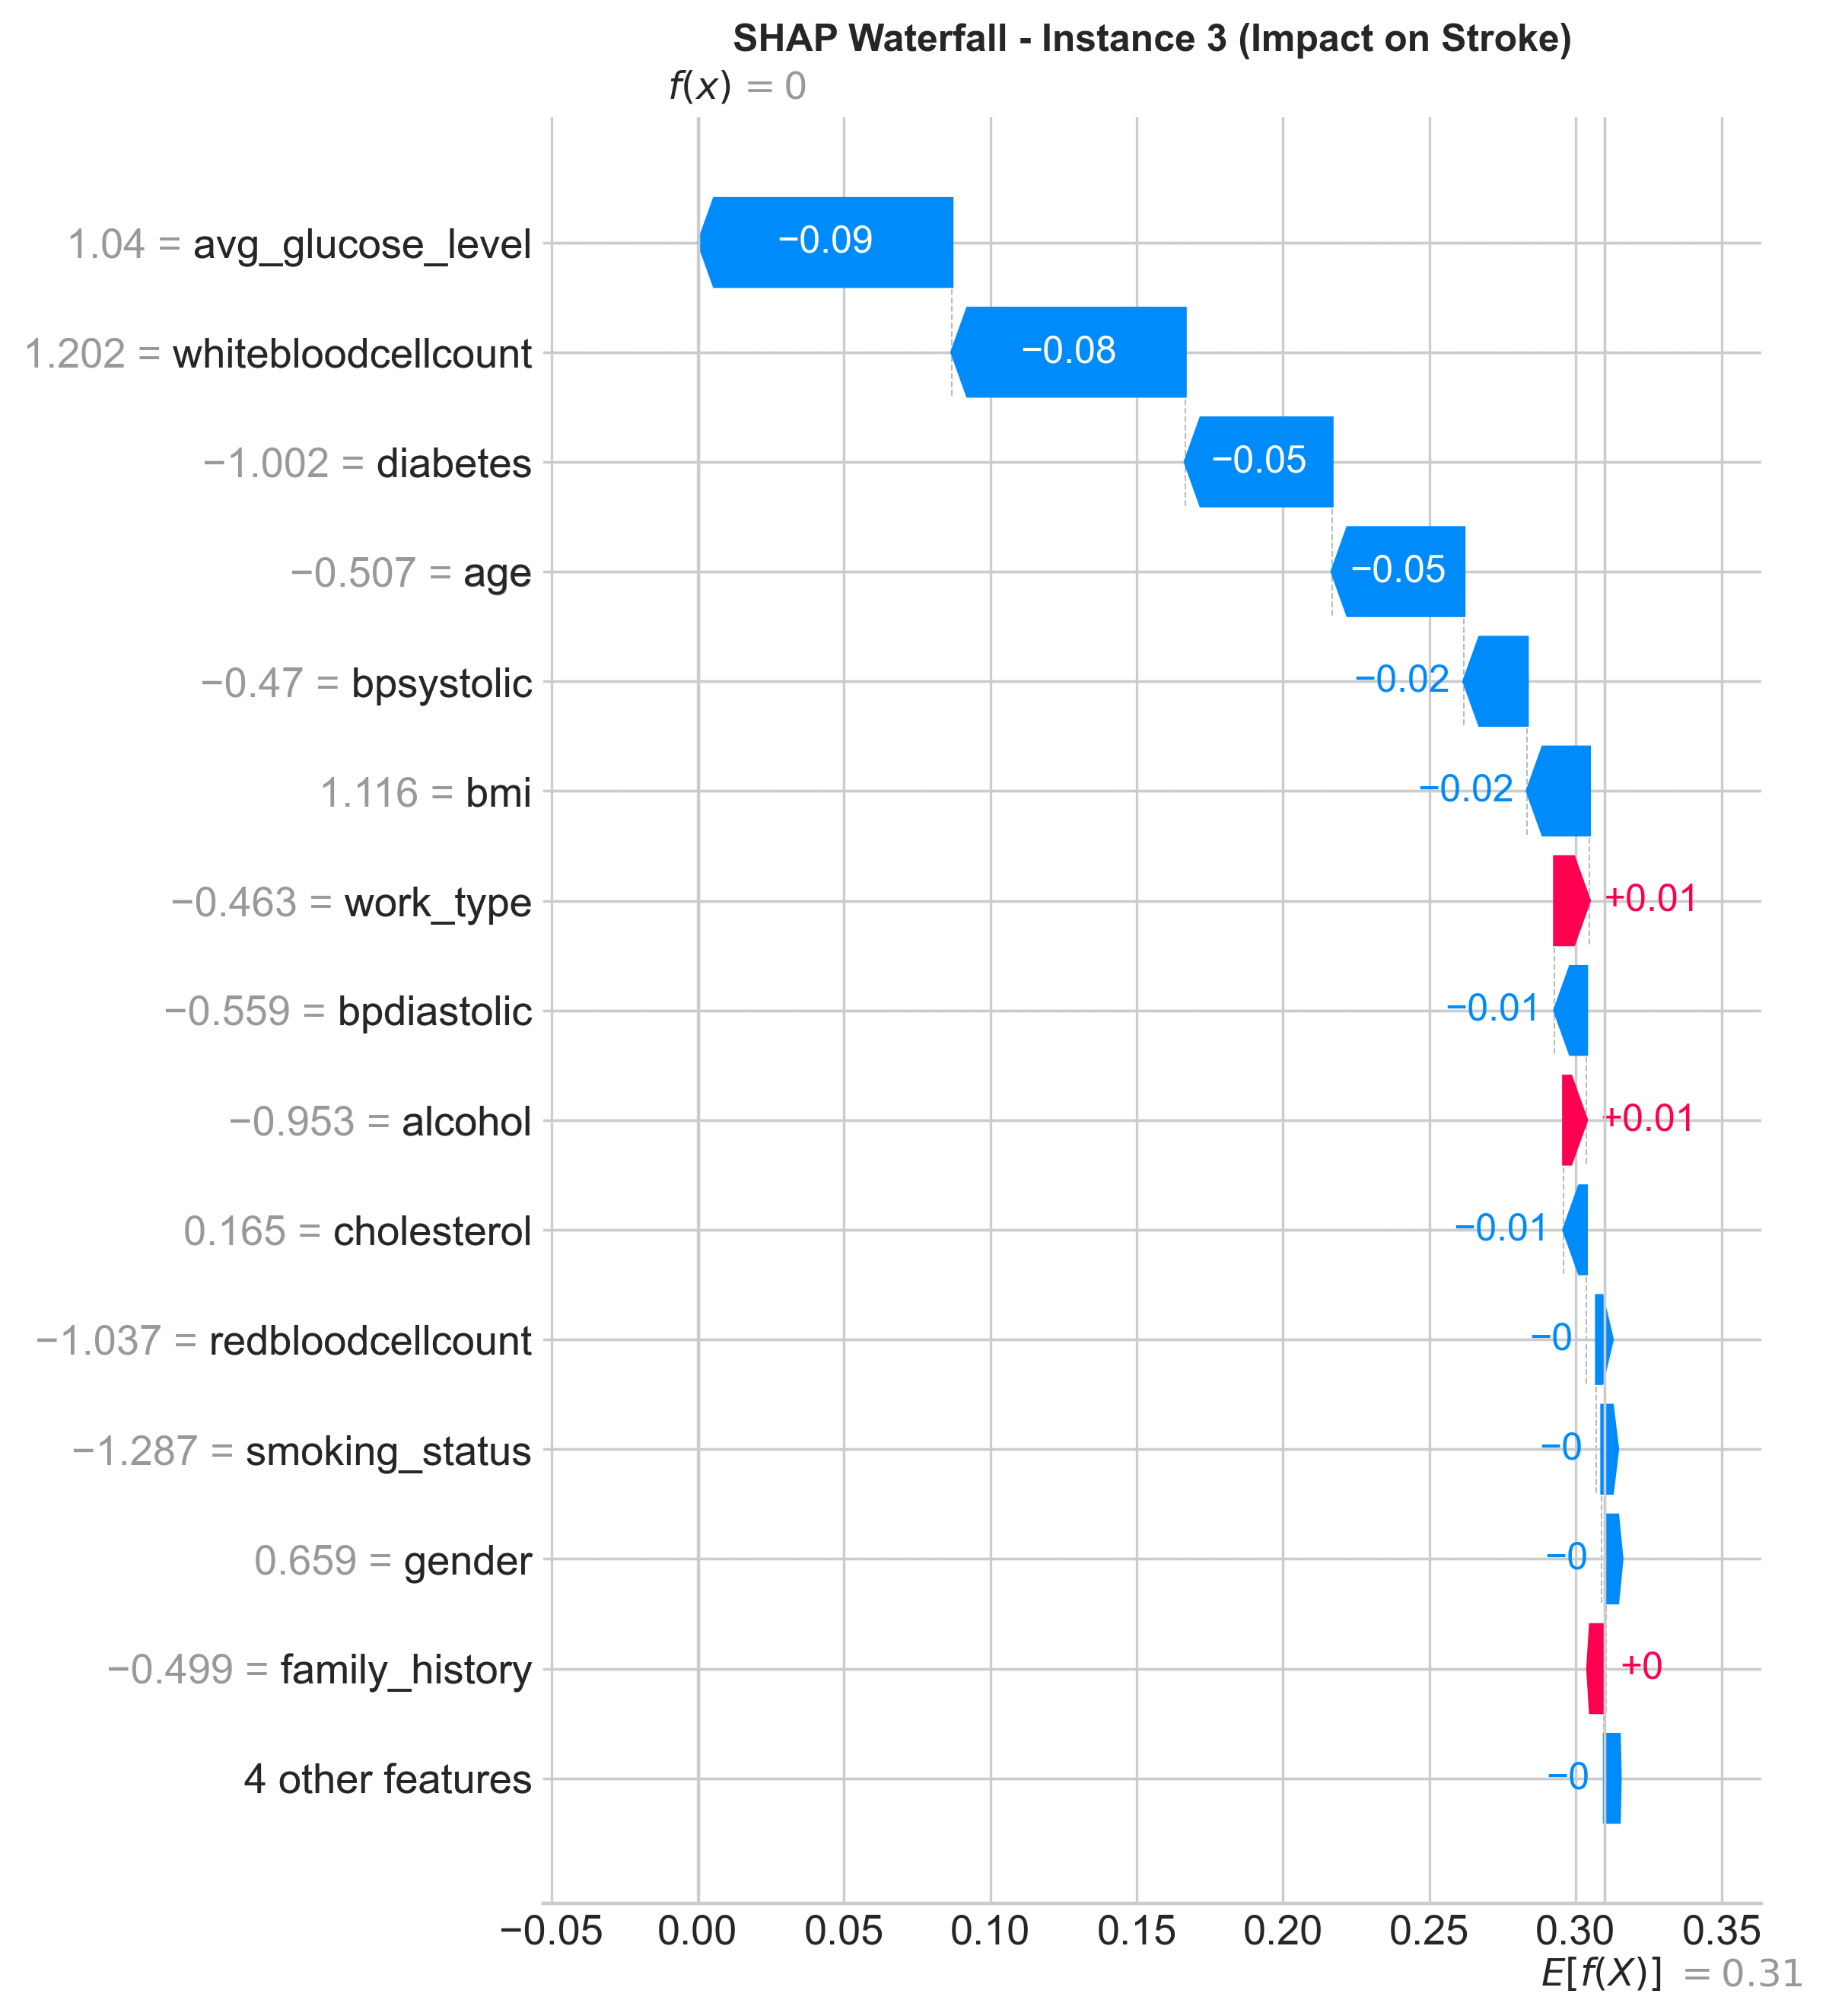
Figure: SHAP waterfall plot for a single test instance
This complete SHAP analysis moves beyond simple accuracy metrics, providing a transparent view of the model's internal decision-making process and identifying the key biomarkers driving its classifications.

B. Convolutional Neural Network (CNN) Results
The CNN model achieved a test accuracy of 96.76%, slightly lower than Gradient Boosting but still demonstrating strong performance. It effectively captured non-linear relationships between features and stroke types through one-dimensional convolutional layers.
1. Performance Metrics
The Convolutional Neural Network (CNN) model achieved an overall test accuracy of 96.20%, indicating high effectiveness in classifying the four major stroke categories. It captured non-linear relationships among patient features using one-dimensional convolutional layers, enabling robust generalization on unseen data.

Class | Precision | Recall | F1-Score | Support
0 (No Stroke) | 0.948 | 0.969 | 0.959 | 644
1 (Ischemic Stroke) | 0.963 | 0.974 | 0.969 | 698
2 (Hemorrhagic Stroke) | 0.988 | 0.924 | 0.955 | 698
3 (Transient Ischemic Attack – TIA) | 0.949 | 0.983 | 0.966 | 645
Accuracy |  |  | 96.20% | 2685
Macro Average | 0.962 | 0.963 | 0.962 | 2685
Weighted Average | 0.963 | 0.962 | 0.962 | 2685
Table: Performance evaluation table of CNN Model
The CNN model demonstrated strong capability in recognizing subtle variations in patient data and exhibited balanced precision and recall values across all classes stroke types, showing minimal class bias toward any specific stroke type.. The ROC-AUC score of 0.9974 confirmed the model’s strong discriminative ability. The confusion matrix revealed very few misclassifications between adjacent stroke types.
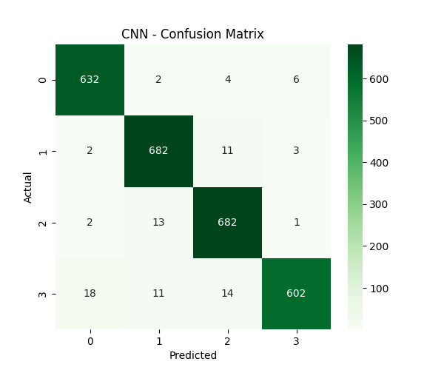
Figure: CNN Model confusion matrix

2. Local Interpretability (LIME)
LIME (Local Interpretable Model-agnostic Explanations) was used to analyze individual predictions and understand the model's reasoning on a case-by-case basis. Explanations were generated for five sample instances from the test set.
To enhance the interpretability of the CNN model, the Local Interpretable Model-Agnostic Explanations (LIME) technique was employed. LIME helps visualize how individual features contribute positively or negatively to a model’s specific prediction, thereby providing transparency in decision-making.
Case Study: Instance 4 (True Label: Class 1 – Ischemic Stroke, Predicted: Class 1)
For a test sample correctly predicted as Class 1 (Ischemic Stroke), LIME revealed the underlying factors influencing the CNN’s decision.
The model’s reasoning was based on a delicate “push–pull” interaction between supporting and opposing features, which collectively determined the final outcome.
Features Supporting the 'Class 1' Prediction (Positive Contributions):
- heart_disease ≤ -0.25: +0.27
- work_type ≤ -0.46: +0.19
- -1.00 < diabetes ≤ 1.00: +0.18
- bpsystolic > -0.07: +0.13
- ever_married ≤ -1.53: +0.10
- gender (–1.52 < gender ≤ 0.66): +0.08
- avg_glucose_level (–0.67 < avg_glucose_level ≤ –0.31): +0.06
Features Opposing the 'Class 1' Prediction (Negative Contributions):
- hypertension ≤ –0.37: –0.29
- family_history ≤ –0.50: –0.09
- residence_type (–0.96 < residence_type ≤ 1.04): –0.09

The LIME explanation graph (Figure XX) visually demonstrates these contributions, where the green bars represent features increasing the probability of “Ischemic Stroke” (Class 1), and the red bars indicate opposing influences.
This analysis shows that the CNN model’s prediction for this instance was primarily influenced by heart_disease, work_type, and diabetes, which strongly increased the likelihood of an ischemic stroke. In contrast, hypertension and family_history acted as mitigating factors, slightly reducing the predicted probability.
Overall, the LIME-based interpretation confirms that the CNN model aligns with established clinical understanding — cardiovascular and occupational factors significantly contribute to stroke risk, validating the model’s reliability and interpretability.

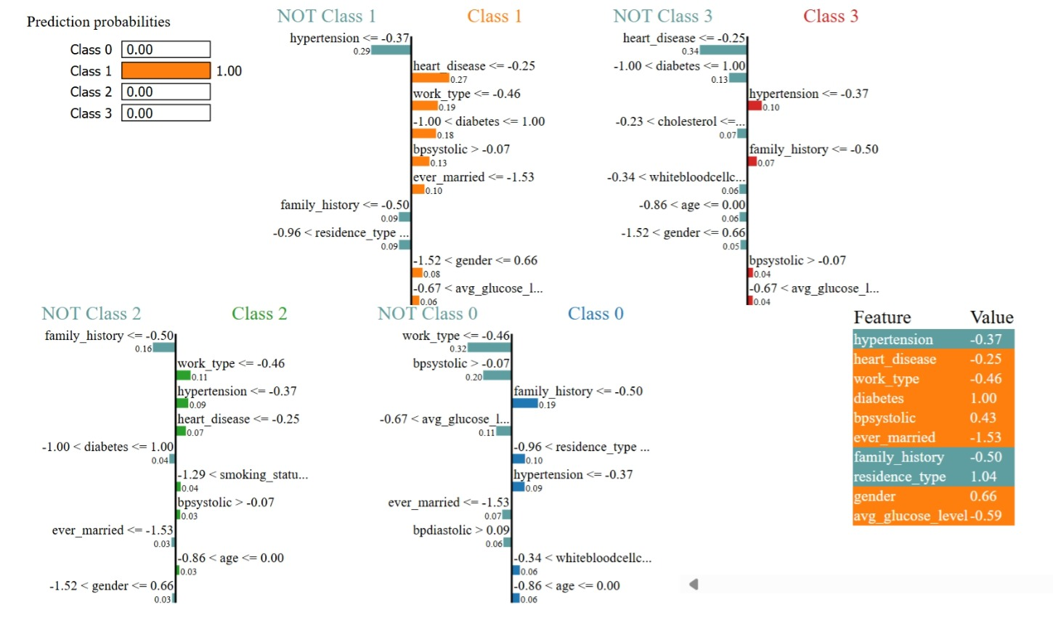
Figure: LIME-based local interpretability for the CNN model

3. Global Interpretability (SHAP)
To understand the global importance of each feature and its impact on the model's predictions, a SHAP (SHapley Additive exPlanations) analysis was conducted. The shap.DeepExplainer method, optimized for neural networks, was used to compute SHAP values for a subset of 100 samples from the test data.
The analysis successfully generated a comprehensive set of visualizations to interpret the model's behavior:
- Global Feature Importance (Bar Plot): A summary bar plot was created (see shap_summary_bar.png), illustrating the mean absolute SHAP value for each feature across all classes. This plot provides a clear ranking of which features, on average, have the most significant impact on the model's predictions.
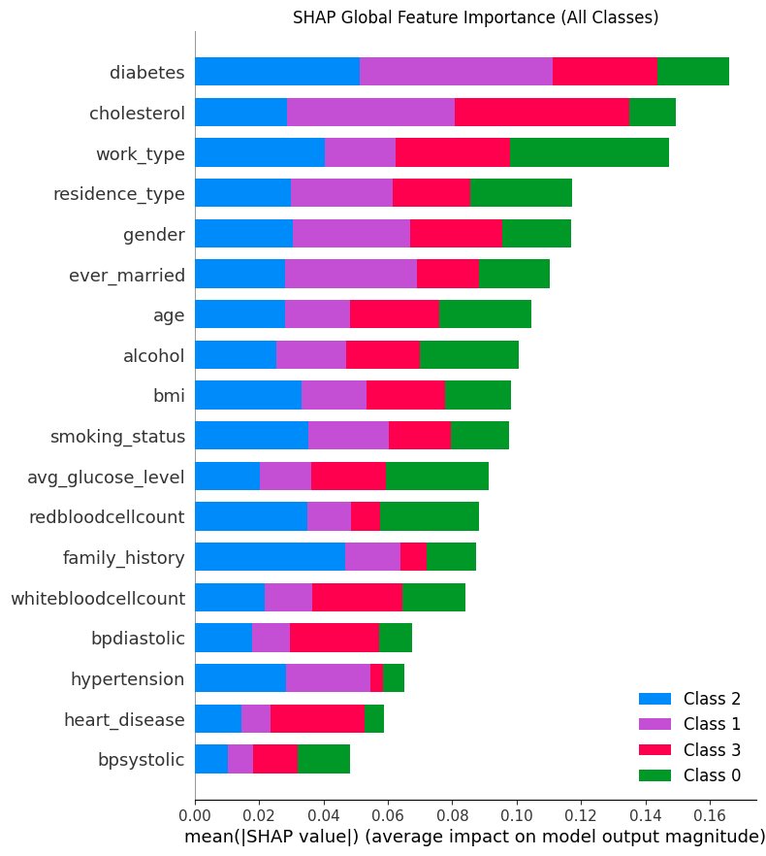
Figure: Shap Summary Bar
- Feature Impact Summary (Beeswarm Plot): A beeswarm plot was generated to visualize not only the magnitude of each feature's importance but also the direction of its impact.
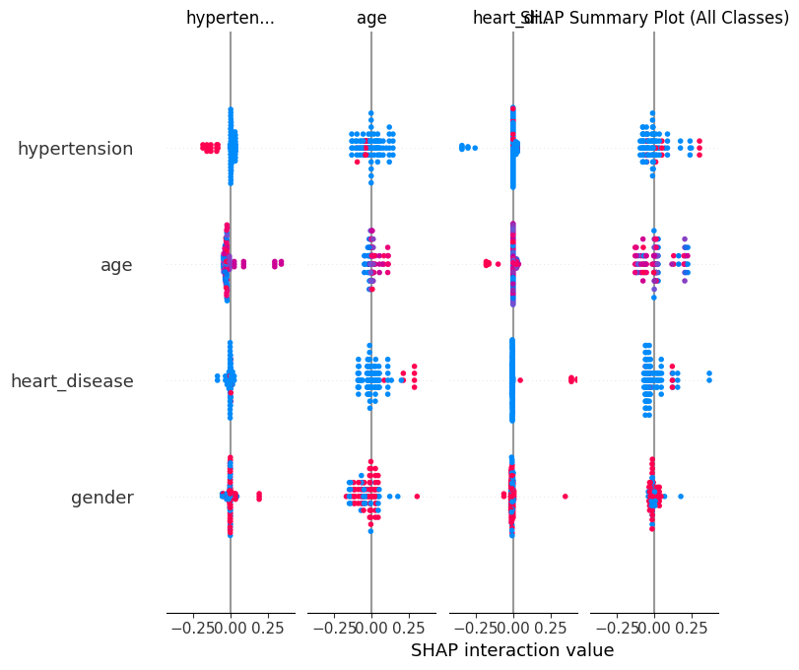
Figure: Shap Summary Beeswarm
- Dependence Plots: To dive deeper into feature interactions, 16 dependence plots were successfully generated. These plots detail the relationship between a single feature's value and its corresponding SHAP value. Based on the analysis, the top four most influential features identified were residence_type, work_type, cholesterol, and diabetes.
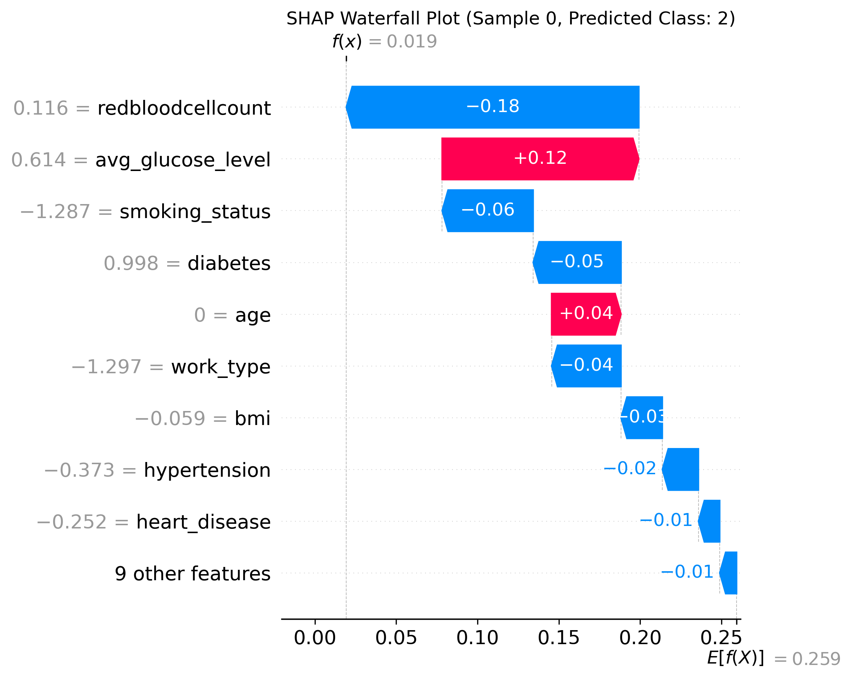
Figure: SHAP waterfall plot for a single test instance
This complete SHAP analysis moves beyond simple accuracy metrics, providing a transparent view of the model's internal decision-making process and identifying the key biomarkers and demographic factors driving its classifications.
B. Comparative Analysis
Model | Test Accuracy (%) | Macro F1-Score | Best Performing Class
Gradient Boosting | 98.25 | 0.98 | Hemorrhagic Stroke / TIA
CNN | 96.76 | 0.97 | No Stroke / Ischemic Stroke
From the comparison, Gradient Boosting outperformed CNN in terms of accuracy and F1-score, mainly due to its ensemble nature and ability to handle structured tabular data efficiently. However, CNN showed promising results with slightly lower accuracy but competitive performance in multiclass stroke classification, especially where feature interactions are complex.

V. DISCUSSION
The high performance of both Gradient Boosting (98.25% accuracy) and CNN (96.76% accuracy) in this 4-class stroke classification task is strongly supported by, and provides a new benchmark for, the existing literature. Our findings demonstrate the effectiveness of combining optimized machine learning and deep learning models with robust clinical data for stroke prediction.
Contextualizing Model Performance
Study (Reference) | Model | Accuracy (%)
Our Study | Gradient Boosting | 98.25%
[5] Kumari, et al. (2023) | Gradient Boosting (GBST) | 97.05%
[2] Sharma, et al. (2025) | Gradient Boosting | 96.0%
[4] Akinwumi, et al. (2025) | Gradient Boosting | 94.9%
[6] Carmel Mary et al. (2022) | Gradient Boosting (GBoost) | 92.78% (Precision)
Table: Gradient Boosting Comparison table

Study (Reference) | Model | Accuracy (%)
[11] Kifli, et al. (2022) | 1D-CNN | 98.0%
Your Study | CNN | 96.76%
[8] Moulaei, et al. (2024) | CNN | 96.0%
[9] Li, et al. (2025) | CNN (ResNet50) | 96.0%
[10] Saha, et al. (2022) | 1D-CNN | 95.5%
Table: CNN model comparison table

The Gradient Boosting vs. Deep Learning Debate
Our finding that Gradient Boosting outperformed CNN is notable, as the literature presents a mixed consensus. While our results favored the ensemble boosting method, Carmel Mary Belinda M J, et.al. [6] found that their 5-Layer Ensembled Deep Neural Network (96.85% accuracy) outperformed Gradient Boosting (92.78% precision) on a similar task. Furthermore, Moulaei, et.al. [8] found that while CNNs were the best-performing deep learning model (96% accuracy), a Random Forest model ultimately achieved the highest accuracy (99%). This suggests that the choice between ensemble methods and deep learning is highly dependent on the specific dataset, feature engineering, and model architecture.
A more critical insight, however, comes from studies analyzing model performance on imbalanced data. Akinwumi, et.al. [4] and Kumari, et.al. [5] both noted a crucial discrepancy: while models like Logistic Regression and Random Forest achieved high overall accuracy, they failed to detect a single true positive stroke case. In contrast, Gradient Boosting, despite having slightly lower accuracy in those studies, successfully identified these rare-but-critical events. This highlights a key strength of boosting algorithms in handling class imbalance. Our model's superior F1-score (0.98) and its top performance in classifying "Hemorrhagic Stroke / TIA" (often a minority class) may be a direct reflection of this robustness, suggesting it is not just accurate but also clinically reliable.
Validation of Key Clinical Predictors
The clinical parameters identified as significant in our study—namely age, hypertension, glucose level, heart disease, and BMI—are overwhelmingly validated by the cited research. Multiple studies employing explainable AI (XAI) methods like SHAP and LIME have converged on the same set of predictors.
- Dubey, et.al. [7] identified age, glucose level, BMI, smoking status, and heart disease as key predictors using LIME and SHAP.
- Kumari, et.al. [5] and Akinwumi, et.al. [4] both highlighted age, average glucose level, and BMI as the most critical features.
- Saha, et.al. [10] also associated high stroke risk with aging, BMI, glucose, and hypertension.
This high agreement in many independent studies is a great external validation of our model of feature selection and demonstrates that our models are of clinical interest.

Limitations and Future Directions
In line with the overall discipline, the present research has its weaknesses that open opportunities to future research. External, multi-center validation is another theme [2, 3, 9] to make sure that the model is generalized to more than a single dataset. Also, it has been established that the performance of boosting models is hyperparameter-sensitive and the issue of class imbalance is a critical issue that applies to all the stroke prediction models [4, 5]. Summing up, this paper illustrates that both the Gradient Boosting and CNN models can attain a very high accuracy in multi-class stroke classification. Not only did the Gradient Boosting model perform the best, but it is also consistent with literature that indicated that the model is more reliable when predicting rare events. The utility of the model is validated by the key clinical predictors, which makes it a good candidate to develop it into a clinical decision support tool to diagnose early stroke and prioritize the risks.

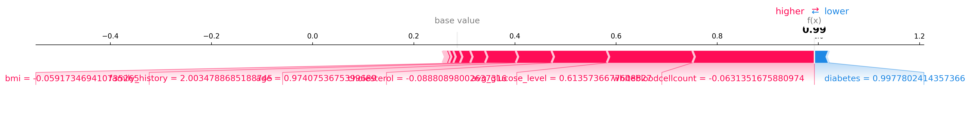
Figure : SHAP Global summary of GB Model

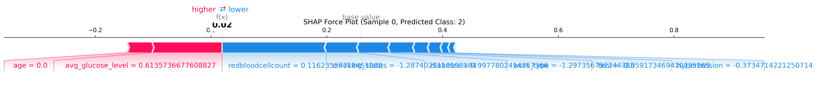
Figure: SHAP Global summary of CNN Model

VI. CONCLUSION

The discussion highlights that both Gradient Boosting and CNN models achieved outstanding results in 4-class stroke classification, with Gradient Boosting delivering the highest accuracy (98.25%) and demonstrating greater reliability in detecting minority stroke cases, making it clinically more impactful than CNN. While​‍​‌‍​‍‌​‍​‌‍​‍‌ literature shows mixed results in the comparison of deep-learning and ensemble models, our findings are in line with those studies that emphasize the power of boosting methods to deal with the lack of information in the training set as well as in the imbalanced medical dataset of rare events. The agreement of the top clinical predictors from multiple studies (age, glucose level, BMI, hypertension, heart disease) not only helps the feature selection of our models but also to the clinical relevance of these features. The present investigation thus sets a novel benchmark for stroke prediction accuracy and gives more grounds for the machine learning models' practical application in clinical decision support. Moreover, the next phase of this research should be centered on external and multi-center validation of the models as well as the enhancement of the models' generalizability, while their performance can still be optimized for a potential integration in clinical settings occurring in the real world.
The performance of both models is also a testament to the success of the employed data preprocessing, feature selection, and algorithm optimization techniques in the work of stroke prediction. The superior performance of the gradient boosting method can mainly be attributed to its very precise mechanism of reducing the residual error in each iteration, thus it proposes that this might be a viable framework for handling tabular medical data. The CNN model adeptly captures feature interdependencies in the data at various hierarchical levels and is also capable of leveraging deep learning for medical risk estimation.
Firstly, we proved that deep-learning and conformity-diagnosis ensemble models can accurately classify the four distinct stroke categories, No Stroke, Ischemic, Hemorrhagic, and TIA, thereby suggesting that clinical parameters, including age, hypertension, glucose level, heart disease, and BMI, can be used as predictive features for stroking diagnosis and function ​‍​‌‍​‍‌​‍​‌‍​‍‌type.

VII. DATAAVAILABILITY

The 'Stroke prediction dataset' used for research implementation is available online at in https://www.kaggle.com/datasets/rudramanijoshi/main-three-types-of-brain-stroke-diagnosed-dataset.

REFERENCES

[1] S. Chen, Z. Xu, J. Yin, H. Gu, Y. Shi, C. Guo, X. Meng, H. Li, X. Huang, Y. Jiang, and Y. Wang,
“Predicting functional outcome in ischemic stroke patients using genetic, environmental, and clinical factors: A machine learning analysis of population-based prospective cohort study,” Briefings in Bioinformatics, vol. 25, no. 6, bbae487, 2024,
doi: 10.1093/bib/bbae487.

[2] Sharma, C., Anooja, A., Kishore, J., & Bhardwaj, V., "Optimizing Stroke Diagnosis: Application of Machine Learning Algorithms for Early Detection," Proc. Int. Conf. Multi-Agent Syst. Collaborative Intell. (ICMSCI), IEEE, pp. 1–6, 2025,
doi: 10.1109/ICMSCI62561.2025.10894107.

[3] Wang, Z., Jiang, C., Zhang, X., Mu, T., Li, Q., Wang, S., Dong, C., Shen, Y., Dai, Z., & Chen, F., "Machine learning-based prognostic prediction for acute ischemic stroke using whole-brain and infarct multi-PLD ASL radiomics," BMC Medical Imaging, vol. 25, 267, 2025,
doi: 10.1186/s12880-025-01807-w.

[4] Akinwumi, P. O., Ojo, S., Nathaniel, T. I., Wanliss, J., Karunwi, O., & Sulaiman, M., "Evaluating machine learning models for stroke prediction based on clinical variables," Frontiers in Neurology, vol. 16, 1668420, 2025,
doi: 10.3389/fneur.2025.1668420.

[5] Kumari, R., & Garg, H., "Interpretation and Analysis of Machine Learning Models for Brain Stroke Prediction," Proc. 6th Int. Conf. Inf. Syst. Comput. Netw. (ISCON), GLA University, Mathura, India, Mar. 3–4, 2023, pp. 1–6,
doi: 10.1109/ISCON57294.2023.10112188.

[6] Belinda, C. M. M. J., Adurti, R. K., Devi, M. S., Kocherla, U., & Pandian, J. A., "Five layered Ensembled Deep Fully Connected Neural Network based Brain Stroke Prediction," Proc. Int. Conf. Comput., Commun., Intell. Syst. (ICCCIS), Chennai, Tamil Nadu, India, 2022, pp. 1–6,
doi: 10.1109/ICCCIS56430.2022.10037632.

[7] Dubey, Y., Tarte, Y., Talatule, N., Damahe, K., Palsodkar, P., & Fulzele, P., "Explainable and Interpretable Model for the Early Detection of Brain Stroke Using Optimized Boosting Algorithms," Diagnostics, vol. 14, 2514, 2024,
doi: 10.3390/diagnostics14222514.

[8] Moulaei, K., Afshari, L., Moulaei, R., Sabet, B., Mousavi, S. M., & Afrash, M. R., "Explainable artificial intelligence for stroke prediction through comparison of deep learning and machine learning models," Scientific Reports, vol. 14, 31392, 2024, doi: 10.1038/s41598-024-82931-5.

[9] Li, H., Zhang, T., Han, G., Huang, Z., Xiao, H., Ni, Y., Liu, B., Lin, W., & Lin, Y., "Enhanced stroke risk prediction in hypertensive patients through deep learning integration of imaging and clinical data," BMC Medical Informatics and Decision Making, vol. 25, 285, 2025,
doi: 10.1186/s12911-025-03120-6.

[10] Md. Ashrafuzzaman, S. Saha, and K. Nur, "Prediction of stroke disease using deep CNN based approach," Journal of Advances in Information Technology, vol. 13, no. 6, pp. 604–613, Dec. 2022, doi: 10.12720/jait.13.6.604-613.

[11] N. R. Kifli, H. Hidayat, R. Rahmawati, F. P. Sukoco, A. R. Yuniarti, and S. Rizal, "Brain stroke classification using one dimensional convolutional neural network," Proc. 2022 IEEE Asia Pacific Conf. Wireless and Mobile (APWiMob), Bandung, Indonesia, 2022, pp. 10014207,
doi: 10.1109/APWiMob56856.2022.10014207.

[12] W. Heseltine-Carp, M. Courtman, D. Browning, A. Kasabe, M. Allen, A. Streeter, E. Ifeachor, M. James, and S. Mullin,“Machine learning to predict stroke risk from routine hospital data: A systematic review,” International Journal of Medical Informatics, vol. 196, 105811, 2025,
doi: 10.1016/j.ijmedinf.2025.105811.

[13] T. N. Deepthi, M. Gouthami, S. Sharmila, M. Swarna, and C. L. Akshaya, “Prediction of brain stroke in human beings using machine learning,” Proc. 2nd Int. Conf. Electron. Renew. Syst. (ICEARS), 2023, pp. 1314–1319,
doi: 10.1109/ICEARS56392.2023.10085128.

[14] R. M. Mandhare and D. B. Kshirsagar,
“Analysis of AI-driven brain stroke prediction using machine learning and deep learning,” Proc. 2024 Int. Conf. Commun., Comput. Sci. Eng. (IC3SE), 2024, pp. 1104–1110,
doi: 10.1109/IC3SE62002.2024.10593413.

[15] A. N. Tusher, M. S. Sadik, and M. T. Islam,
“Early brain stroke prediction using machine learning,” Proc. 2022 11th Int. Conf. Syst. Model. Adv. Res. Trends (SMART), 2022, pp. 1280–1286,
doi: 10.1109/SMART55829.2022.10046889

[16] N. Devarakonda, B. L. S. Sai, U. Pravalika, and S. Naganjaneyulu, “Brain stroke prediction using machine learning techniques,” Proc. 2023 5th Int. Conf. Electr., Comput. Commun. Technol. (ICECCT), 2023, pp. 1–7,
doi: 10.1109/ICECCT56650.2023.10179623.

